North County Food Policy Council/San Diego Food System Alliance
Introduction to the NCFPC GIS Tool (August 2022)

The North County Food Policy Council, a working committee of The Alliance for Regional Solutions (www.regionalsolutions.net), is indebted to Palomar College for the partnership which makes this tool available. Spring and Fall semester GIS students contribute additions and updates for service-learning credit. We also note the partnership of the San Diego Food System Alliance (www.sdfsa.org)helping to make this GIS platform useful in addressing food insecurity throughout the San Diego region.

Four Palomar College Spring 2022 GIS students continued the work of adding and updating mapped information to this GIS tool, to provide a comprehensive platform to assess both food insecurity, and resources, to meet food needs in the San Diego region. There work consisted of:
- Updating an older community gardens layer with 2022 County-wide data, including a wealth of information about each garden program, capacity, participant rules, visitor hours and more
- Updating a layer of public schools meals programs, with 2021 County-wide data showing types of meals provided (morning, and/or lunch, and even evening in some cases)

These updated map layers add to the work of previous Palomar GIS students. Also notable, added in Spring 2019, is a polygon layer showing a calculated estimate by zip code area of informal single family dwelling backyard tree fruit production, which gleaning operations should be able to recover; both to reduce solid waste, and for food assistance to the food insecure. This very conservative estimate comes from Karen Clay/My Momma’s Place, https://mymommasplace.com/

Pull up and explore this Web-based GIS tool using the navigation instructions below, to understand the layers and attributes for each layer. Also below is a complete listing of all of the GIS data layers available in this tool.

ACCESSING AND NAVIGATING THE GIS TOOL

From the Alliance for Regional Solutions Web home page (www.regionalsolutions.net), under Committees in the top menu bar, click on North County Food Policy Council; on that page, find the large blue button, “GIS Mapping System.” Click on that button - and the current GIS map will load up. The initial (default) screen will look like this –
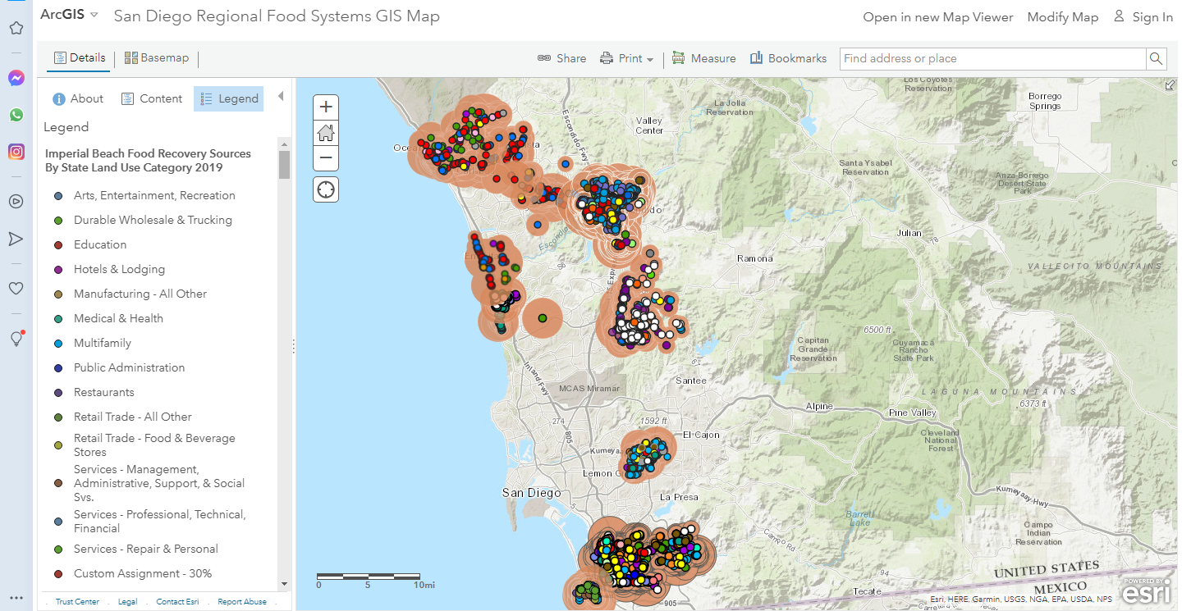
This is the “default” load-up of this tool. Only some of the available data layers are active and displayed; YOU have the ability of turning off and on different layers, explained below. The default layers are cities’ potentially recoverable food data. On the left-hand, “legend” side of the screen, is the explanation of symbols of the active layers. (You can scroll up and down to see the legends for all active layers.) On the right-hand side is the map the display of the active layers.
The legend explains each currently-active GIS layer. The legend describes what each type of layer is, with their different symbols and colors on the map. Again, you can turn on and off all of the different layers, for different comparisons between items. (For example, you may want to see the location and adjacency of nonprofit food assistance agencies/programs, and schools, or faith centers, for partnership opportunities.) Each of the layers displayed on the map are points, or lines, or areas (polygons) on the map.
In the very left upper-hand corner, note that “details” is underlined. To the right of “details” is “basemap.” You can click on this button to bring up choices of different underlying basemaps, depending on your desires/needs. Play with this to see what may work best for you at any time!
- Not yet active in the default map are additional layers; many are polygons (areas). In addition to city boundaries (very useful to see resources in specific jurisdictions), other polygon layers are displays of backyard gleaning potential, community areas by concentrations of several demographic (population) characteristics, indicators of potential food insecurity: poverty, Hispanic population, older age, younger age, households receiving SNAP (food stamps), single parent/guardian households. There is also a polygon layer of federally-defined food insecurity. (The Food Policy Council’s initial work confirmed that these population demographics are associated with food insecurity.) Again, YOU have the capability of turning on and off these demographic indicators (instructions below).

On the right-hand side of the screen is the map of active layers. Three things:
- If you mouse-click right on top of any one of the point, line or polygon symbols, information details (“attributes”) of that one item will show on the screen. Play with this to see what information is available here on each type of item in each layer.
- If you go to an area of the map without any symbol, mouse-click and hold, you can move the map around to different community areas.
- In the upper-left hand corner of the map, are buttons allowing you to zoom in, and zoom out. You can zoom out to see the whole state or country; and you can zoom way, way in to any particular location.

- Here’s how to turn on and off the different map layers:

Back on the left-hand side of the screen toward the top, note that “Legend” is highlighted and active.
- Mouse click on “Content” button right next to Legend. Note that the left-hand side now changes, and you can click to check on, or check off, any one of the layers included in this GIS map. Those layers active by default are already checked; others are not checked, and you can activate them.
- Among the layers are ten demographic items, concentrations of:
- Hispanic population;
- Black population;
- people below 18 years;
- people 65 years and older;
- two different displays of poverty, by absolute numbers in any polygon, and by percentage of total population in a polygon;
- food insecurity;
- Households receiving SNAP (food stamp) assistance
- Unemployment
- Single parent/guardian households
- Normally, you will want to have only one of these polygon layers active at any time, as the overlapping colors will be confusing. For any of these demographics, the darker the color of the polygon, the higher the concentration; so that darker colors are concentrations of persons potentially food-insecure. The legend display will tell you the concentration for any color. For most of these layers, the polygons are census block groups; polygons for the USDA food insecurity layer are census tracts.
There are also other polygon layers showing census tract boundaries, and cities’ boundaries; and the polygon layer showing backyard gleaning potential by zip codes. Besides all these polygon displays are point and line data layers – all described below. Again, turn on and off to see single items, or compare multiple items with each other.

This is a good beginning for exploring the North County Food Policy Council GIS map, care of Palomar College and the San Diego Food System Alliance. Below is a complete listing of all of the data layers available in this tool. There is much more information/functionality in this Web tool, which you are free to explore!

EXISTING NCFPC GIS DATA LAYERS (as of August 2022)
except where noted, all of these cover the full San Diego County region
Polygon layers:
- Estimate of potential for gleaning backyard tree produce, by zip code
- Concentration of food insecurity (US Census/USDA defined), % of population, in census tracts
- Concentration of poverty, % of population, in census block groups
- Concentration of poverty, absolute numbers of persons, in census block groups
- Concentration of older age, 65+, absolute numbers, in census block groups
- Concentration of young age, 18 and under, absolute numbers, in census block groups
- Concentration of ethnicity Hispanic, absolute numbers, in census block groups
- Concentration of racial group Black, absolute numbers, in census block groups
- Concentration of households receiving SNAP food assistance, absolute numbers, in census block groups
- Concentration of numbers of persons unemployed, census block groups (2019)
- Numbers of single parent or guardian households, differentiated by single women and single men, in census block groups
- Municipal boundaries, all cities in region and County unincorporated
- U.S. Census tracts, boundary outlines
Line layers:
- Public transit, full County region: routes by type (also see point layers: stations/stops, and ¼ mile access)
Point layers:
- Comprehensive food outlets by type; 5 categories, as licensed by County Health 2021
- Food agencies/programs which partner with San Diego Food Bank; red circles, the larger the circle the greater the total volume of food that agency/program received for public distribution from the Food Bank in 2020
- Food agencies/programs which partner with Feeding San Diego; light purple circles, the larger the circle the greater the total volume of food that agency/program received for public distribution from Feeding SD in 2020
- Public school based Summer meal programs, 2021
- Nonprofit public school partners: public schools which partner with food agencies’ specific programs (Feeding San Diego, San Diego Food Bank, Vista Teen Outreach, Provisions Relief Team, Got Your Back, Respect Project/Sheriff’s Dept.) for food assistance to students/families; the larger the circle the greater the total volume of foods that school-based program distributed in 2016
- Public schools County wide, by type (elementary, middle, high school, charter, alternative, continuation, special education, County community, K-12)
- Healthcare Facilities, full County region, 2021
- Public transit, full County region: stops/stations
- Public transit, full County region: ¼ mile access radius around each station/stop
- Farmers markets, full County region, 2020
- Community gardens, full County region, 2022
- County of San Diego unincorporated, SB1383 commercial edible food generators, by business type
- County of San Diego unincorporated, SB1383 commercial edible food generators, by SB1383 Tier 1 and Tier 2
- City of Imperial Beach, AB 1826/SB 1383 generators of potentially recoverable food, by type of generator, 2020
- City of Imperial Beach, AB 1826/SB 1383 generators of potentially recoverable food, by volume of food waste, 2020
- City of Poway, AB 1826/SB 1383 generators of potentially recoverable food, by type of generator, 2019
- City of Poway, AB 1826/SB 1383 generators of potentially recoverable food, by volume of food waste, 2019
- City of Encinitas, AB 1826/SB 1383 generators of potentially recoverable food, by type of generator, 2019
- City of Encinitas, AB 1826/SB 1383 generators of potentially recoverable food, by volume of food waste, 2019
- City of Solana Beach, AB 1826/SB 1383 generators of potentially recoverable food, by type of generator, 2019
- City of Solana Beach, AB 1826/SB 1383 generators of potentially recoverable food, by volume of food waste, 2019
- City of Chula Vista, AB 1826/SB 1383 generators of potentially recoverable food, by type of generator, 2019
- City of Chula Vista, AB 1826/SB 1383 generators of potentially recoverable food, by volume of food waste, 2019
- City of Del Mar, AB 1826/SB 1383 generators of potentially recoverable food, by type of generator, 2018
- City of Del Mar, AB 1826/SB 1383 generators of potentially recoverable food, by volume of food waste, 2018
- City of La Mesa, AB 1826/SB 1383 generators of potentially recoverable food, by volume of food waste, 2018
- City of La Mesa, AB 1826/SB 1383 generators of potentially recoverable food, by type of generator, 2018
- City of Oceanside, AB 1826 generators of potentially recoverable food, by type of generator, 2017
- City of Oceanside, AB 1826 generators of potentially recoverable food, by volume of food waste, 2017
- City of Vista, AB 1826 generators of potentially recoverable food, by type of generator, 2017
- City of Vista, AB 1826 generators of potentially recoverable food, by volume of food waste, 2017
- City of San Marcos, AB 1826 generators of potentially recoverable food, by type of generator, 2017
- City of San Marcos, AB 1826 generators of potentially recoverable food, by volume of food waste, 2017
- City of Escondido, AB 1826 generators of potentially recoverable food, by type of generator, 2017
- City of Escondido, AB 1826 generators of potentially recoverable food, by volume of food waste, 2017
- Public schools for full County region, by % student enrollment qualifying for subsidized meal
- Faith centers (North County only)

